West Tennessee Vocal Music Educators Association proudly presents

All-Northwest Honor Choir

November 13th -15th
Hosted by Freed-Hardeman University

Senior High Honor Choir
Clinician: Francis Cathlina
Accompanist: Lisa Powell
Chair: Jared Heldenbrand
Chair: Tasha Moore

Junior High Honor Choir
Clinician: Brian Kittredge
Accompanist: Benjamin Duffey
Chair: Alex Key
Chair: Naomi Burns

WTVMEA and the Northwest Choir Chairs would like to thank First United Methodist Church for their hospitality in allowing us to rehearse and Freed-Hardeman University for allowing us to present our concert here this afternoon.

Good afternoon,

I am Reachel Hudgins, and it has been my pleasure to serve as the West Tennessee Vocal Music Educators Association President for the past two years. Having the privilege to serve music students and teachers over the course of this term is a joy and a highlight of my career as an educator. Attending events like All Northwest Honor Choir, Choral Performance Assessment, and All State Honor Choir has confirmed what I already knew to be true: that Tennessee has some of the most talented students and educators in the country. They are hardworking and dedicated musicians who represent the very best that Tennessee has to offer.

It warms my heart to see so many families here today who value a Fine Arts education and the importance of the lessons that education provides for our students. Lessons like time management, the importance of deliberate practice and rehearsal, and, of course, the invaluable concept of working together as a team. These students support and encourage each other. They celebrate each other’s victories and share the burden of their disappointments together, becoming not only teammates, but friends and family as well. So, I say thank you to the families, friends and teachers who have supported these students in their endeavor to become better musicians, because in doing so, you’ve helped them to become better students, better sons and daughters, and better human beings.

In a world that often pulls us apart, music persistently draws us back together. One concert, one song, one simple note has the power to unite. And this afternoon, this concert does just that—bringing us together to feel the joy only music can give. For a brief moment, we set aside everything else and open ourselves to what these students have poured their hearts into: a reflection of their shared humanity.

Reachel Hudgins
WTVMEA President

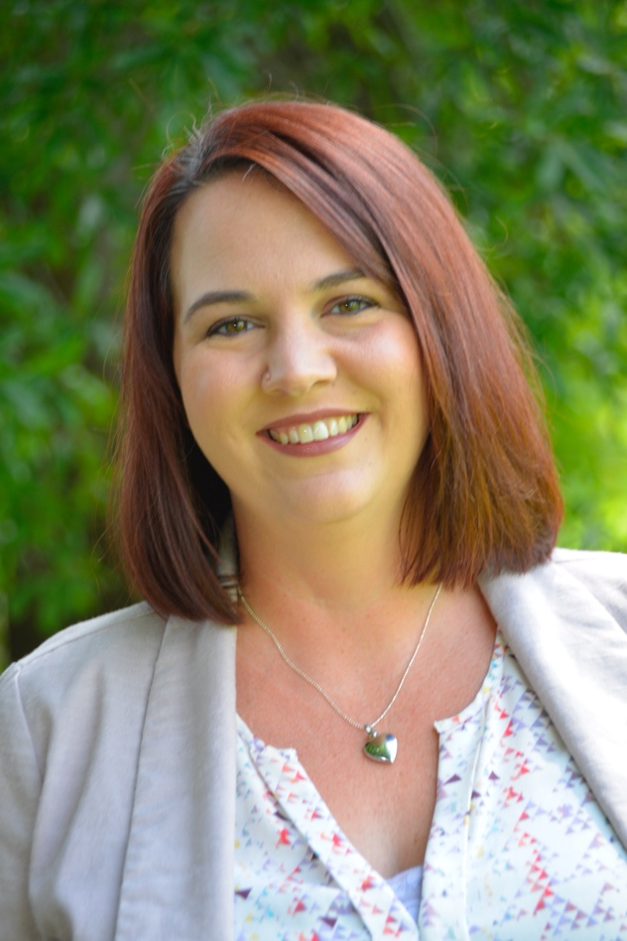
Reachel Hudgins is the Director of Vocal Music and Theater at Dyer County High School in Newbern, Tennessee. This year she began her twentieth-year teaching in the Dyer County School System.
Reachel is a 2004 graduate of Lambuth University where she earned bachelor’s degrees in Vocal Performance and Music Education.
In addition to her teaching position, Reachel has served in various leadership positions in local and state associations. She served as the WTVMEA All State Choir coordinator for eight years, TMEA State Choral chair from 2018-2020, and currently serves as President for WTVMEA. She also serves on the TMEA Council. Reachel has been a member of WTVMEA and TMEA for 21 years.
Reachel has been married to her wonderful husband, Jonathan, for 24 years and they have three beautiful daughters. She is a member of First Baptist Church in Troy, Tennessee where she is on the Praise and Worship Team. In her free time, she enjoys traveling and spending time with her family.



Francis Cathlina, D.M.A. (he/him) is a Vietnamese-American conductor and educator, renowned for his innovative approach to choral music. His concerts invite audiences into a world where choral artistry becomes a powerful storytelling medium.

Dr. Cathlina serves as the Director of Choral Activities at the University of Memphis, where he oversees the Choral Area, leads the MM/DMA Choral Conducting program, and conducts the University Singers. His creative work was recognized with the 2025 Dean’s Award for Creative Achievement.

A two-time GRAMMY-nominated educator, Dr. Cathlina draws on his Eastern heritage to cultivate a collaborative pursuit of excellence. In 2025, he served as the Choral Conducting Faculty for Brazil’s FIMUS Festival and worked in the Philippines as part of ACDA’s International Conductors Exchange Program. Early recognition came from the Texas Choral Directors Association (TCDA), which named him a “Young Director of Distinction.”

Cathlina’s teaching develops masterful technicians, expressive communicators, and thoughtful citizens. Under his direction, the UofM University Singers have been invited to perform for national conferences. His students lead prominent programs—as university DCAs and symphony chorus directors. Recent/upcoming engagements include the 2028 Kentucky All-State Choir, the 2027 Arkansas All-State Choir, and a Carnegie Hall debut. Of all these, conducting honor choirs remains his most cherished creative work.

An authority on vocal pedagogy, Dr. Cathlina's research focuses on choral tone and conducting gesture. He has presented over 75 sessions worldwide. He is published in international journals. In 2025, he headlined the Ohio and Alabama choral conferences. In 2023, he co-led Conducting Masterclasses in Greece with the University of Macedonia (Thessaloniki) and Ionian University (Corfu).

Dr. Cathlina earned a DMA in Conducting with a Vocal Pedagogy cognate from the University of North Texas, an MM from Michigan State University, and a BME from Baylor University. Before his doctorate, he taught in Texas public schools. Beyond the podium, he is a UDRIPPIN-sponsored pickleball athlete/coach. He, his husband Kyle, and their dog Coco call Memphis, Tennessee, their home.

In concert, Cathlina wears an áo dài, traditional Vietnamese formalwear. As one of the few Vietnamese conductors in the field, he proudly dons it as a tribute to his heritage. www.franciscathlina.com



Ms. Powell received her B.A. in Music Education from Calvin College in Grand Rapids, Michigan and then spent a decade directing Junior and Senior High bands in Michigan and Ohio. Lisa lived in Jackson, Tennessee for 19 years, from 2005 to 2024, and was invested in a variety of both musical and ministry opportunities. She served as Director of Music at Grace United Methodist Church from 2010 to 2024, Staff Accompanist and Music Director of Renaissance Theater at Bethel University from 2011 to 2019 and was the director of bands at Sacred Heart of Jesus High School and also the University School of Jackson.

Lisa moved to Columbus, Ohio, in 2024 and is now the Director of Bands at Horizon Science Academy Charter High School. She also serves as an accompanist for BalletMet Columbus, Otterbein University, and Capital University.

Lisa always looks forward to serving as a Collaborative Artist for the All-Northwest Senior High Honor Choir and has had this privilege since 2008. She also collaborated with TMEA All-State Choirs from 2018 to 2024. And in 2021 and 2022, Lisa was the accompanist for the National Association of Music Education (NAfME) All-National Choir under the direction of Frances Fonza.

Lisa makes as many trips to Tennessee as she can to see her kids Julia, Jesse, and Joanna.

Senior High Honor Choir

Soprano
Brianna Tucker Madison Academic Magnet HS
Reiley Lombardia Tipton Christian Academy
Kate Donahoo Tipton-Rosemark Academy
Grace Gallimore Henry County High School
Hayden Hight University School of Jackson
Ally Ruth Morris Chester County High School
Kenslee University School of Jackson
Kytana Ramos Southside High School
Savanna Hinton Madison Academic Magnet HS
Penelope Gaskin Chester County High School
Kenslee Santos Chester County High School
Victoria Wade Henry County High School
Nora Manley Madison Academic Magnet HS
Bella Quinn Tipton Christian Academy
Emily Puckett Henry County High School
Elaina Rogers Henry County High School
Alli Smith Chester County High School
Mary Blake Ferguson University School of Jackson
Aleyah Wilson Haywood High School
Lily Fields Henry County High School
Charis Lawson Family Christian School
Meredith Butler Milan High School
Gabriella Khattar Tipton-Rosemark Academy
Molly Newborn Madison Academic Magnet HS
Portia Bradshaw Chester County High School
Addy Kirkland University School of Jackson
Emme Williamson Tipton-Rosemark Academy
Khloe Adams Ripley High School
Laryah Coleman Ripley High School
Aubrey Watson Henry County High School
Claire Russell University School of Jackson
Abby Claire Crider Trinity Christian Academy
Lola Agbetoyin University School of Jackson
Kayla Truss Covington High School
Lily Latham Covington High School
Katelyn Myatt Family Christian School
Noellee Flores Covington High School
Eden Denton South Gibson County High School
Kaleigh Waldron Covington High School
Madison Hopper Chester County High School
Evie Moran Jackson Christian School
Jordan Smith Scotts Hill High School
Savanna Hinton Madison Academic Magnet HS
Ally Ruth Morris Chester County High School
Kenslee Santos Chester County High School
Vivianne Neely University School of Jackson
Penelope Gaskin Chester County High School
I’Yonna McKinnie Chester County High School
Kendall Yopp Chester County High School
Naomi Blair Tipton-Rosemark Academy
Eliza Dorris University School of Jackson
Kenzie Loeffel Milan High School
Natalie Fite University School of Jackson
Lilly Chattin Madison Academic Magnet HS
Delia Sigler Tipton-Rosemark Academy
Catherine Palmer Henry County High School
Bryleigh Dill Madison Academic Magnet HS
Chloe Bruce Dyersburg High School
Ericka Perez Covington High School
Malia Hopkins Madison Academic Magnet HS
Ansleigh Dill Madison Academic Magnet HS
Elise Simpson Madison Academic Magnet HS
Farrah McDurmon Henry County High School
Maggie Elder Tipton Christian Academy
Mallory Collins Henry County High School
Addie Mae Womble Chester County High School
Annie French Henry County High School
Anna Badgett University School of Jackson
Calleigh Hammer Union City High School
Taylor Hill Covington High School
Monica Tims Tipton Christian Academy
Armani Carter Dyersburg High School
Ava Crowder Madison Academic Magnet HS
Sabrina Foster McNairy Central High School
Jacqueline Hernandez McNairy Central High School
Elyse Cunningham Gibson County High School
Anna Chapman Gibson County High School
Alto
*Finley Homesley Henry County High School
Annie Burcham Union City High School
Phoebe Coleman Union City High School
Maleah Torres Brighton High School
Campbell Kelley Munford High School
Carlie Thompson Henry County High School
Jaqueline Gwatney Trinity Christian Academy
Judi-Kaye Justice Dyersburg High School
Ainsley Leonard McNairy Central High School
Katie Jane Carter Tipton Christian Academy
Kylee Yelverton Chester County High School
Peyton Butcher Munford High School
Karmen Ayala Madison Academic Magnet HS
Willow Shopher Brighton High School
Shelby Moore McNairy Central High School
Briley Dodd South Gibson County High School
Riley Taylor Tipton-Rosemark Academy
Evangeline Gaskin Chester County High School
Julissa Mack Union City High School
Emily Talley Milan High School
Gabrielle Collins North Side High School
Anna Joy Bragg Trinity Christian Academy
Kyleigh Finch Madison Academic Magnet HS
Jaqueline Medbury Henry County High School
Gabby Young Henry County High School
Jade Jackson Henry County High School
Bridget Medlin Crockett County High School
Ava McCalla Covington High School
Jaleigh Murley McNairy Central High School
Anna Barnett Chester County High School
Sarah Cannon Madison Academic Magnet HS
Sadie James Milan High School
Marleigh Grant Dyersburg High School
Maggie Norris University School of Jackson
Chloe Hudson University School of Jackson
Andee Damron Henry County High School
Elaina Norvell South Side High School
Molly Vanstory Brighton High School
Miracle Patterson McNairy Central High School
Isabel Dougan Madison Academic Magnet HS
Aydan Leath Chester County High School
Piper Lawson Family Christian School
Aarna Mehta University School of Jackson
Olivia Jones Henry County High School
Brynlee Seay Dyersburg High School
Addie Patterson Madison Academic Magnet HS
Logan Barnhart Henry County High School
Aspen Sturgis University School of Jackson
Olivia Roane Tipton Christian Academy
Sophie Amburn University School of Jackson
Emma Claire Hughey Covington High School
*Sloane Russell Henry County High School
Faith White Tipton Christian Academy
Anna Overton Milan High School
Sophia Plyler Madison Academic Magnet HS
Myren Hurst Dyersburg High School
Allyson Snyder Madison Academic Magnet HS
Andromeda Gaskin Chester County High School
Sarah MoodyPoe Henry County High School
Brynlee Allen Family Christian School
Aaleyah Medlin Tipton Christian Academy
Ruby Hines University School of Jackson
Elyse Bell Family Christian School
Nora Scott Tipton-Rosemark Academy
Brooklyn Reed South Gibson County High School
Evie Fuller Dyer County High School
Grace Leland Covington High School
Briley Dodd South Gibson County High School
Kelsie Bond North Side High School
Lily Boals South Gibson County High School
Susana Jimenez Chester County High School
Gabriella Kammanee Chester County High School
A’Nevah Davis Henry County High School
Alivia Olson South Gibson County High School
Maya Tate Covington High School
Tenor
Owen Wade Henry County High School
Piper Bevan Henry County High School
Rheagan Hicks University School of Jackson
Abrianna Miser Covington High School
Landon McAdams Union City High School
Houston Hellmer Madison Academic Magnet HS
Mason Green Henry County High School
Angelo Khatter Tipton-Rosemark Academy
Tristan Rogers Madison Academic Magnet HS
Colleen Kennedy Family Christian School
Ty Hooper Madison Academic Magnet HS
Toby Lawson Family Christian School
Hollis Bates Henry County High School
Ayden Carnell Chester County High School
Brycen Sikes Madison Academic Magnet HS
Jason Jordan Madison Academic Magnet HS
Trey Jackson Union City High School
Brandt Huffstutter Union City High School
Eli Barber Milan High School
Joshua Johnson Tipton-Rosemark Academy
Parker George Trinity Christian Academy
Caden Kennedy South Side High School
LaDarious Taylor Covington High School
Noah Goode Covington High School
Noah Martin University School of Jackson
Laila Bills Haywood High School
Diego Montoya University School of Jackson
*Grady Hutson Henry County High School
Griffin McDurmon Henry County High School
Bryant Dunagan Chester County High School
Tucker Robertson Jackson Christian School
Saul Ramirez Henry County High School
Ty Tyler Tipton-Rosemark Academy
Jordan Crawford Madison Academic Magnet HS
Isaiah Thomas Dyersburg High School
Elijah Lickey South Gibson County High School
Quentin Jackson Dyersburg High School
Matthew Exline South Gibson County High School
Asher Allbritton Henry County High School
Dylan Newman Covington High School
Colton Newville Henry County High School
Thomas Richardson Henry County High School
Isaiah McManus Henry County High School
Landon Parks Madison Academic Magnet HS
Graeson Carter Brighton High School
Riley James Hughes Tipton-Rosemark Academy
Kelan Tucker Gibson County High School
Jordan Smith South Side High School
Nathan Foster Gibson County High School

Bass
Gavin Horn Family Christian School
Preston Price Madison Academic Magnet HS
Nathan Finch Union City High School
Aydon Isbell University School of Jackson
Jacob Hobson Henry County High School
Chris Topps Covington High School
Vander Burchett Tipton-Rosemark Academy
Nate Roberson Jackson Christian School
Colton Gary Union City High School
Keanon King Ripley High School
Kaleb Allen Tipton Christian Academy
Jayden Bills North Side High School
Cooper Wiley Madison Academic Magnet HS
Owen Bona Dyersburg High School
D’Quarte Rivers Dyersburg High School
Caleb Rogers Chester County High School
Donovan Johnson Chester County High School
Harlan Smith Milan High School
Eli Harrell Ripley High School
Christian Lockhart Liberty Technology High School
Sam White Tipton Christian High School
Jack Channell Covington High School
Jacquez Townsend Ripley High School
Zachary Crane Tipton-Rosemark Academy
Peyton Byler Dyersburg High School
Trad Longeway Madison Academic Magnet HS
Keaton Roberson Henry County High School
Canaan Barrow Henry County High School
Cameron Smith Ripley High School
Tylon Hill Chester County High School
Grayson Upton Madison Academic Magnet HS
Luke Gateley Family Christian School
Luke Martin South Gibson County High School
Matt Murray University School of Jackson
Isaac Price Henry County High School
Trace Griffin Tipton Christian Academy
Landon Hatchel Tipton-Rosemark Academy
Brayden Entsminger Family Christian School
Caedon Goodrum Tipton-Rosemark Academy
Sam Cross Henry County High School
Isaiah Burton North Side High School
Jacarri Cherry South Side High School
Jason Lamb Henry County High School
Isaac Smith Dyersburg High School
Caleb Roaten Henry County High School Aidan McManis South Gibson County High School
Weston Smith Tipton-Rosemark Academy
Jaxson Hoy Munford High School
Jayden Williams Chester County High School
Ronnie Williams Dyersburg High School

(* Denotes soloists)

PROGRAM

Gloria (SATB, F.J. Haydn)

I Shall Not Live in Vain ​(SATB, Patrick Vu)

My Soul’s Been Anchored (SATB, Moses Hogan)

There Was a Time (SATB, Elaine Hagenberg)

Tshela Moya Kenna Yo Morena (SATB, Michael Barrett)

Dr. Brian Kittredge is Professor of Music and Director of Choral Activities at the University of Alabama at Birmingham, where he conducts the University Concert Choir, Chamber Singers, and teaches courses in conducting and music education. Under his direction, the UAB Choirs have gained a strong presence regionally, nationally, and internationally.
Dr. Kittredge has led the UAB Concert Choir in performances at the 2023, 2020, 2016, and 2012 Alabama Music Educators Conferences, the 2020 ACDA Southern Region Conference, the 2018 Gotham Sings Choral Festival in Carnegie Hall, the 2017 London Sangerstevne and Cante Rode International Choral Festivals in England and The Netherlands, and the 2014 Interkultur 8th World Choir Games in Riga, Latvia, where the choir earned Gold and Silver medals in three categories. The Concert Choir has commissioned several works by notable composers, including works by K. Lee Scott, Michael Trotta, Richard Burchard, Glenn McClure, and Stacey V. Gibbs. The UAB Choirs under his direction maintain an active touring schedule, with concert appearances throughout the United States and abroad. Most recently, the UAB Concert Choir was invited to perform the 2023 World Premiere performance of Michael Trotta’s Requiem, a multi movement masterwork for choir, soloists, and orchestra. In June of 2024, the UAB Concert Choir performed the European Premiere of the work in Florence and Rome, Italy
Prior to his appointment at UAB, Dr. Kittredge served on the faculty at Louisiana State University, where he taught courses in choral conducting and conducted the LSU Schola Cantorum. He taught middle and high school at the Louise S. McGehee School in New Orleans, LA, where his choirs appeared in performances at state, regional, and international festivals, and consecutive performances at the Independent Schools Association of the Southwest (ISAS) Arts Festival in Dallas, TX and Tulsa, OK.
Dr. Kittredge is an active clinician and guest conductor, and has appeared at choral festivals in Alabama, Arkansas, California, Florida, Georgia, Louisiana, Missouri, Mississippi, New York, South Carolina, Virginia, and Tennessee. He was the guest conductor of the 2016 Organization of American Kodaly Educators National Chamber Choir in Long Beach, CA; has held positions on the Board of Alabama ACDA; and is an active member of the National Association for Music Educators (NAfME), the American Choral Directors Association (ACDA), the National Collegiate Choral Organization (NCCO), and the College Music Society (CMS). For over twenty years, Dr. Kittredge has served on the administrative and artistic faculty at the New York State Summer School of the Arts, where his choirs appeared in concerts at the Chautauqua Institute and SUNY Fredonia. Dr. Kittredge holds a Doctor of Musical Arts degree from Louisiana State University (2011, Kenneth Fulton- mentor), a Master of Music degree from the Eastman School of Music (2004, William Weinert- mentor), a Bachelor of Music degree from Mansfield University (2002, Peggy Dettwiler- mentor), and is a distinguished graduate of the Rod Serling School of Fine Arts at Binghamton High School (1998, Sue Bachman, Barbara Powell, Michael Saarie- mentors).

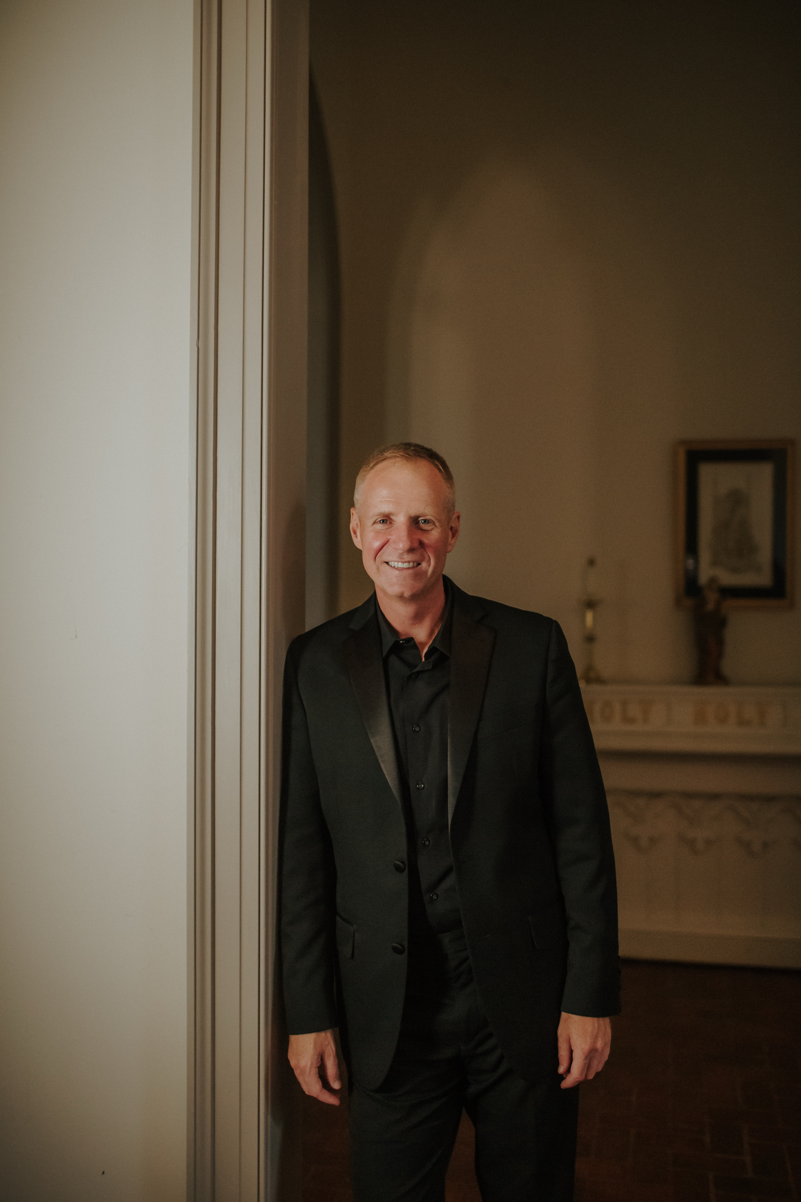

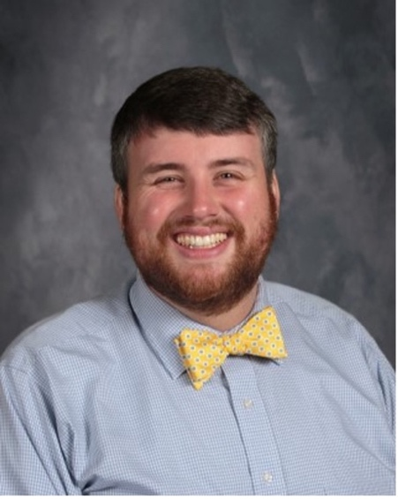

Benjamin has been fortunate to accompany the All-Northwest Junior High Choir for the past 12 years. He is the Special Education and Pre-K supervisor at Bells City School, and he serves as pianist at First Baptist Church in Bells. Benjamin accompanies for Kincaid-Gooch Voice Studio and subs on keyboard for traveling musical theatre productions at the Orpheum Theatre in Memphis. He lives with his wife Christina and daughters Joely and Kay in Alamo.

Junior High Honor Choir
Soprano
Laynie Word Murray Inman Middle School
Erin Duke Madison Academic Magnet HS
Cali Langley Tipton Christian Academy
Anna Byrd University School of Jackson
Katie Tipton Dyersburg High School
Sarah Gay University School of Jackson
Lilly Ford Tipton-Rosemark Academy
Maddie White Dyersburg Middle School
Bishop Gorman University School of Jackson
Tori Cook University School of Jackson
Ally Hinson Dyersburg High School
Eleanor Chattin Madison Academic Magnet HS
Zoe Paschall Dyersburg High School
Jovie Allen Family Christian School
Abby Wiley Madison Academic Magnet HS
Caroline Kirkland University School of Jackson
Grace Wagner University School of Jackson
Adelaide Glass Tipton Christian Academy
Sophie Varino University School of Jackson
Sophia Hawkins Tipton Christian Academy
Taylor Sanders Covington Middle School
Gabriella Flores Dyersburg Middle School
Mazie Jones McNairy Central High School
Mirabel Roszell Chester County Jr. High School
Tamia Odum Munford Middle School
Isabella Hammond Jackson-Central Merry Early College High
Adelyn Mitchell Westover Elementary School
Kylie Harrah Haywood High School
Lynnlee Houston Dyersburg Middle School
Kaylee Bullock Pope School
A’Mya Avery Covington Middle School
Karin Houtz Madison Academic Magnet HS
Gracelyn Wood Chester County Jr. High School
McKenzie Sharp Madison Academic Magnet HS
Lexie Overton Chester County Jr. High School
Alyvia Baxter Madison Academic Magnet HS
Molly Kate Phelps Tipton-Rosemark Academy
Charlotte Mount Madison Academic Magnet HS
Sophia Warfel Milan Middle School
Rowan Mayo Madison Academic Magnet HS
Lilly Sanders Dyersburg Middle School
Evelyn Garcia Dyersburg High School
Brintlee Wylie Dyersburg Middle School
Asher Higdon Milan Middle School
Harper McCall Milan Middle School
Gabrielle Bartholomew Milan Middle School
Charlotte Hamilton Madison Academic Magnet HS
Justice Mullins Chester County Jr. High School
Haley Hogue Dyersburg High School
JulieAnne Cundiff Dyersburg High School
Kinley Bryowsky Milan Middle School
Cate Fite University School of Jackson
Josie Van Dyke Dyersburg Middle School
Samantha Holt Milan Middle School

Alto
Kayler Grace Hopkins University School of Jackson
Mattie Allen University School of Jackson
Shaila Patel University School of Jackson
Claire James Milan Middle School
Addi McVay McNairy Central High School
Hadley McAfee McNairy Central High School
Olive Barnett Inman Middle School
Noelle Ross Tipton-Rosemark Academy
Avery Jones Tipton-Rosemark Academy
Hazel Shell Tipton-Rosemark Academy
Makaylah Lewis Covington Middle School
Emma Jones Munford Middle School
Jane Rezk Madison Academic Magnet HS
Bella Seratt Dyersburg Middle School
Kallie Andersen McNairy Central High School
Carrington Currie Community Montessori School
Allie Boaz Tipton-Rosemark Academy
Lily Smith University School of Jackson
Ella McLemore University School of Jackson
Annalee McKee Tipton Christian Academy
Ivy Glenn Tipton-Rosemark Academy
Caroline Short University School of Jackson
Ann Elizabeth Davis Dyersburg Middle School
Jace Allison Cantu Dyersburg Middle School
Tysianna Pirtle North Side High School
Ella Jowers Tipton Christian Academy
Isabel Dougan Community Montessori School
Avery Cecil Dyersburg Middle School
Anna Overton Milan Middle School
Ella Jowers Tipton Christian Academy
Ella Holyfield Munford Middle School
Reese Seratt Dyersburg Middle School
Claire Wilson Milan High School
Kaylee Murray Henry County Middle School
Addison Goertz Madison Academic Magnet HS
Grace Whetstone Madison Academic Magnet HS
Callie Wren Trinity Christian Academy
Abigail Archie Milan High School
Ava Moore Inman Middle School
Gabby Campbell Dyersburg Middle School
Kennedy Pruitt Munford Middle School
Julia Hamilton Dyersburg High School
Callie Smith Family Christian School
Avery Shepherd Munford Middle School
Sophia Goodwin Tipton-Rosemark Academy
Olivia Lindley University School of Jackson
Katherine Rogers Dyersburg Middle School
Jolie Jones University School of Jackson
Clementine Pettit Madison Academic Magnet HS
Gabby Knott Family Christian School
Laini Hearn Chester County Jr. High School
Margo Bush University School of Jackson
Baley Eno Dyersburg Middle School

Tenor
Cash Moore Chester County Jr. High School
Elijah DuBose Madison Academic Magnet HS
Owen Simmons Inman Middle School
Jeremiah Wolfe Tipton Christian Academy
Jones Wooten Tipton Christian Academy
Cort Marcum Inman Middle School
Liam Farrow Chester County Jr. High School
Michael Williamson Madison Academic Magnet HS
Grey Salonus University School of Jackson
Zach Brasfield University School of Jackson
Josh Hicks Dyersburg Middle School
Ben Croom University School of Jackson
Raine Shearon Dyersburg Middle School
David Tyler Henry County Middle School
Bennett Murray University School of Jackson
Connor McGregor Milan Middle School
Hayden Medlin Inman Middle School
Ivan Paschall Inman Middle School
Sail Via University School of Jackson
Chase Lee Milan High School
Charlie Thompson University School of Jackson
Drew Whitledge University School of Jackson
Ford Scallions University School of Jackson
Kayden Hadley-Rommel Haywood Middle School
Jaylin Lake Chester County Jr. High School
Malcolm Scott University School of Jackson Graham Taylor University School of Jackson
Bryson Humphrey Dyersburg Middle School
John Cundiff Dyersburg Middle School
Evan Barnett Inman Middle School
Julian Parsons St. Mary’s Catholic School
Bass
Jackson Pierce Dyersburg Middle School
Everette Teague University School of Jackson
Camden Coltrane Tipton Christian Academy
Landon Jones Madison Academic Magnet HS
Josiah Gray Madison Academic Magnet HS
Jacks Henry Weaver University School of Jackson
Kadian Morrow University School of Jackson
Jude Stone Dyersburg Middle School
William Hight University School of Jackson
Kaleb Cole Northeast Middle School
Zayn Johnson Chester County Jr. High School
Mason Hathcock Haywood Middle School
Larry Jace Cupples Chester County Jr. High School
Haynes Stoots University School of Jackson
Pavan Nerwal University School of Jackson
Smith Nabours University School of Jackson
Caysen Baskerville University School of Jackson
Alex Hester St. Mary’s Catholic School
Hudson Hellmer Madison Academic Magnet HS
Caleb Chance Madison Academic Magnet HS
Parker Morat University School of Jackson
Tommy Mulliniks Madison Academic Magnet HS
Sam Alvey University School of Jackson
Jacob Cook Dyersburg Middle School
Wyatt Pugh University School of Jackson
Landon Merrell Henry County Middle School
Isaac Keel Jackson Christian School
Juilen Tipler West Bemis Middle School
Elijah Roy Dyersburg Middle School

PROGRAM

Ad Astra (SATB, Jacob Narverud)
Alleliua (SATB, Wolfgang Amadeus Mozart arr. Patrick M. Liebergen)
Music of Life (SATB, B.E. Boykin)

To order recordings of the 2025 All-Northwest Honor Choir concerts,
please scan the QR code
and order online at www.havmedia.com
Al Shlosha (SATB, Allan E. Naplan)
Where the Light Begins (SATB, Susan LaBarr)
NDA Wanna (SATB, Michael Barrett)
Shine on Me (SATB, Rollo Dillworth)



